It’s Coming!
Friday, March 24th
7:00 pm

Tune in to “The Lutheran Hour”
Hear this inspirational message on CKRM at 7:30 am Sunday
March 12
"Thirsting for Life"
Guest Speaker: Rev. Dr. John Nunes
Jesus gives living water to those who are spiritually dehydrated.
(John 4)

Welcome to Worship
Sunday March 5th, 2023
Second Sunday of Lent

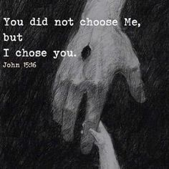

Information for the Feb 12th bulletin can be emailed
to cthomas@sasktel.net
Please send prayer requests for Feb 12th
To: Pastorpaulobrum@gmail.com

SERMON
“BORN AGAIN”
– (John 3:3) “

www.facebook.com/newbeginningslutheranchurch
#NBLCinstagram
Email: newblchurch@gmail.com
Website: nblc.ca

Schedule
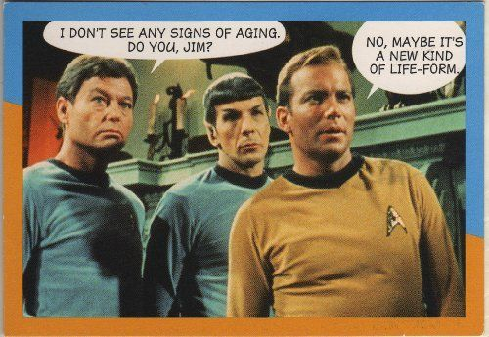
March Birthdays
March 12 – Colin
March 3 – Kathleen
March 5 – Robin
March 5 – Angela
March 9 – Brenda
March 14 – Gilles
March 22 – Wayne
March 27 – Peter
March 27 – Kathy
March 30 - Emil

WARD, Dale –
August 25
LEPAGE, Ila –
August 28
ANTONOWITSCH, Shelby – August 31
BRUM, Silvana H. – August 31

Readers Mar 5 - Laverne Hautz

Mar 12 – Deanna Hautz
Mar 19 – Kaye Loustel
Mar 26 – Rhondda Halkyard

Communion March 5th and 19th

Coffee Mar 5 - Marilyn
Mar 12 – Penny
Mar 19 – Kathy
Mar 26 - Dot
In the Holy Week, we will have follows Services/activities:
* April 2, 11:11 am - Palm Sunday Service
* April 5, 6:30 pm - Passover Seder (Basement)
* April 7, 7pm - Good Friday Service
* April 9, 11:11 am - Easter Service

Worship Mar 5 - Phoenix

Mar 12 – Phoenix
Mar 19 – CTBF
Mar 26 - CTBF
Worship 11:11 AM every Sunday
Pastor Paulo Brum
Ministry: All of Us
306-584-7729 (Church Cell)
You can reach Pastor Paulo Brum at
pastorpaulobrum@gmail.com or 306-807-1858.
*Login for Linksys19680 WiFi network is xy040rdkkt

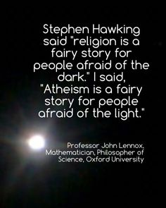
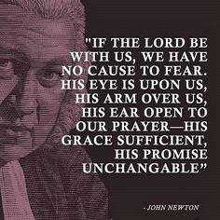
.

In-person attendance last Sunday was 50 people
Thank you for this week’s offerings totaling $5715.00.
Praise God!
Each one must give as he has decided in his heart

Psalm Psalm 121
I lift up my eyes to the hills. From where does my help come? ² My help comes from the Lord, who made heaven and earth. ³ He will not let your foot be moved; he who keeps you will not slumber. ⁴ Behold, he who keeps Israel will neither slumber nor sleep. ⁵ The Lord is your keeper; the Lord is your shade on your right hand.
⁶ The sun shall not strike you by day, nor the moon by night. ⁷ The Lord will keep you from all evil: he will keep your life.⁸ The Lord will keep your going out and your coming in from this time forth and forevermore.

OLD TESTAMENT’ READING Genesis 12:1-9
Now the Lord said^{[a]} to Abram, “Go from your country^{[b]} and your kindred and your father's house to the land that I will show you. ² And I will make of you a great nation, and I will bless you and make your name great, so that you will be a blessing. ³ I will bless those who bless you, and him who dishonors you I will curse, and in you all the families of the earth shall be blessed.”^{[c]}
⁴ So Abram went, as the Lord had told him, and Lot went with him. Abram was seventy-five years old when he departed from Haran. ⁵ And Abram took Sarai his wife, and Lot his brother's son, and all their possessions that they had gathered, and the people that they had acquired in Haran, and they set out to go to the land of Canaan. When they came to the land of Canaan, ⁶ Abram passed through the land to the place at Shechem, to the oak^{[d]} of Moreh. At that time the Canaanites were in the land. ⁷ Then the Lord appeared to Abram and said, “To your offspring I will give this land.” So he built there an altar to the Lord, who had appeared to him. ⁸ From there he moved to the hill country on the east of Bethel and pitched his tent, with Bethel on the west and Ai on the east. And there he built an altar to the Lord and called upon the name of the Lord. ⁹ And Abram journeyed on, still going toward the Negeb.

READING OF EPISTLE Romans 4:1-8, 13-17
What then shall we say was gained by Abraham, our forefather according to the flesh? ² For if Abraham was justified by works, he has something to boast about, but not before God. ³ For what does the Scripture say? “Abraham believed God, and it was counted to him as righteousness.” ⁴ Now to the one who works, his wages are not counted as a gift but as his due. ⁵ And to the one who does not work but believes in^{[a]} him who justifies the ungodly, his faith is counted as righteousness, ⁶ just as David also speaks of the blessing of the one to whom God counts righteousness apart from works: ⁷ “Blessed are those whose lawless deeds are forgiven, and whose sins are covered; ⁸ blessed is the man against whom the Lord will not count his sin.” ¹³ For the promise to Abraham and his offspring that he would be heir of the world did not come through the law but through the righteousness of faith. ¹⁴ For if it is the adherents of the law who are to be the heirs, faith is null and the promise is void. ¹⁵ For the law brings wrath, but where there is no law there is no transgression. ¹⁶ That is why it depends on faith, in order that the promise may rest on grace and be guaranteed to all his offspring — not only to the adherent of the law but also to the one who shares the faith of Abraham, who is the father of us all, ¹⁷ as it is written, “I have made you the father of many nations” — in the presence of the God in whom he believed, who gives life to the dead and calls into existence the things that do not exist.

(continued next page)

(continued on next page)

Offerings – There are a several ways to submit an offering:
- In person Sundays or drop off during the week
- Mail – NBLC 1037 Victoria Ave. S4P 0N6 -Regina
- Etransfer – lutheranchurchnewbeginnings31@gmail.com
Question – “name our pastor”

“

“God created the world out of nothing; so as long as we are nothing, He can make something out of us.” - Luther
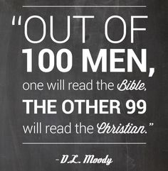
Save the Date! Camp Lutherland’s Spring Fundraiser Supper will take place at Mount Olive on Sun, May 7, from 5-7pm with caterer Daryl Mang! “Tickets” are $40 with receipts given for anything over $20. Mark Raedeke of Prince of Peace will look after the Silent Auction and Bake Sale table. We are going digital so you can do etransfer on our Camp Lutherland website to reserve your ticket; or email clutherland@gmail.com or call Diane @ 1-306-723-4321 to reserve your ticket and pay cash/cheque upon arrival. In Jesus’ Name, thank you for your support!

Camp Lutherland is looking for about a dozen simple wooden crosses (like the former Lutheran Life confirmation ones or something similar that is not breakable) to hang in each of the 14 dorms at the Lodge, as we are advertising ourselves as a Christian Retreat Center. Please bring to Mount Olive by the May 7th supper. Again, thank you for your support!

READING OF THE GOSPEL John 3:1-17
Now there was a man of the Pharisees named Nicodemus, a ruler of the Jews. ² This man came to Jesus^{[a]} by night and said to him, “Rabbi, we know that you are a teacher come from God, for no one can do these signs that you do unless God is with him.” ³ Jesus answered him, “Truly, truly, I say to you, unless one is born again^{[b]} he cannot see the kingdom of God.” ⁴ Nicodemus said to him, “How can a man be born when he is old? Can he enter a second time into his mother's womb and be born?” ⁵ Jesus answered, “Truly, truly, I say to you, unless one is born of water and the Spirit, he cannot enter the kingdom of God. ⁶ That which is born of the flesh is flesh, and that which is born of the Spirit is spirit.^{[c]} ⁷ Do not marvel that I said to you, ‘You^{[d]} must be born again.’ ⁸ The wind^{[e]} blows where it wishes, and you hear its sound, but you do not know where it comes from or where it goes. So it is with everyone who is born of the Spirit.”
⁹ Nicodemus said to him, “How can these things be?” ¹⁰ Jesus answered him, “Are you the teacher of Israel and yet you do not understand these things? ¹¹ Truly, truly, I say to you, we speak of what we know, and bear witness to what we have seen, but you^{[f]} do not receive our testimony. ¹² If I have told you earthly things and you do not believe, how can you believe if I tell you heavenly things? ¹³ No one has ascended into heaven except he who descended from heaven, the Son of Man.^{[g]} ¹⁴ And as Moses lifted up the serpent in the wilderness, so must the Son of Man be lifted up, ¹⁵ that whoever believes in him may have eternal life.^{[h]16} “For God so loved the world,^{[i]} that he gave his only Son, that whoever believes in him should not perish but have eternal life. ¹⁷ For God did not send his Son into the world to condemn the world, but in order that the world might be saved through him.

